Throughout our service today, you’ll notice God being referred to as ALMIGHTY. In recognizing God this way; we acknowledge that God has all power and is omnipotent over us all. When we see God this way, we understand that all of us, rich or poor (or somewhere in between) are totally dependent on the grace and mercy that our almighty God extends to us. And when He does, God expects us to do the same.
- Pastor Randy

Crescentville & Frankford Memorial United Methodist Churches

Sixteenth Sunday after Pentecost September 25, 2022

Welcome

Chorus of Welcome “The Family of God”
I’m so glad I’m a part of the family of God—I’ve been washed in the fountain, cleansed by His blood!
Joint heirs with Jesus as we travel this sod; for I’m part of the family, the family of God.

Call to Worship Psalm 91

Whoever goes to the Lord for safety, whoever remains under the protection of the Almighty,
can say to him, “You are my defender and protector. You are my God; in you I trust.”
God will keep you safe from all hidden dangers and from all deadly diseases.
God will cover you with his wings; you will be safe in his care; his faithfulness will protect
and defend you. You need not fear any dangers at night or sudden attacks during the day
or the plagues that strike in the dark or the evils that kill in daylight.

Opening Hymn “Praise to the Lord, the Almighty” # 139

Praise to the Lord, the Almighty, the King of creation! O my soul, praise Him, for He is thy health
and salvation! All ye who hear, now to His temple draw near; join me in glad adoration!

Praise to the Lord, who o’er all things so wondrously reigning bears thee on eagle’s wings,
e’er in His keeping maintaining. God’s care enfolds all, whose true good He upholds.
Hast thou not known His sustaining.

Praise to the Lord, who doth prosper thy work and defend thee; surely His goodness and mercy
here daily attend thee. Ponder anew what the Almighty can do, who with His love doth befriend thee.

Praise to the Lord, who doth nourish thy life and restore thee, fitting thee well for the tasks that are ever
before thee. Then to thy need God as a mother doth speed, spreading the wings of grace o’er thee.

Praise to the Lord! O let all that is in me adore Him! All that hath life and breath, come now
with praises before Him! Let the amen sound from His people again; gladly forever adore Him.

Opening Prayer

Almighty God, the Life of the faithful and the Joy of the righteous:
Mercifully receive the prayers of all who call upon You, that the souls which thirst
for Your promises may be filled from Your abundance; Through Jesus Christ our Lord,
who lives and reigns with You and the Holy Spirit, one God for ever and ever. Amen.

Children’s Message

Joys & Concerns………………….……..Gathered Prayer…………………………The Lord’s Prayer

Our Father, who art in heaven, hallowed be Thy name; Thy kingdom come, Thy will be done,
on earth as it is in heaven. Give us this day our daily bread; and forgive us our trespasses and debts as we forgive our debtors and those who trespass against us. And lead us not into temptation,
but deliver us from evil. For Thine is the kingdom, and the power, and the glory, forever. Amen.

Gifts and Offerings

Offertory “The Giving Song”

The Doxology “Praise God, From Whom All Blessings Flow” # 95

Praise God, from whom all blessings flow; praise Him, all creatures here below;
praise Him above, ye heavenly host; praise Father, Son, and Holy Ghost. Amen.

The Offertory Prayer

Hymn “Lord, I Want to Be a Christian” [VS. 1-2, 4] # 402

Lord, I want to be a Christian in my heart, in my heart; Lord, I want to be a Christian in my heart.
In my heart, in my heart, Lord, I want to be a Christian in my heart.

Lord, I want to be more loving in my heart, in my heart; Lord, I want to be more loving in my heart.
In my heart, in my heart, Lord, I want to be more loving in my heart.

Lord, I want to be like Jesus in my heart, in my heart; Lord, I want to be like Jesus in my heart.
In my heart, in my heart, Lord, I want to be like Jesus in my heart.
Lord, I want to be like Jesus in my heart.

Gospel Lesson St. Luke 16:19-31

[Jesus said] “There was a certain rich man who clothed himself in purple and fine linen,
and who feasted luxuriously every day. ²⁰ At his gate lay a certain poor man named Lazarus
who was covered with sores. ²¹ Lazarus longed to eat the crumbs that fell from the rich man’s table.
Instead, dogs would come and lick his sores.
²² “The poor man died and was carried by angels to Abraham’s side. The rich man also died
and was buried. ²³ While being tormented in the place of the dead, he looked up and saw Abraham
at a distance with Lazarus at his side. ²⁴ He shouted, ‘Father Abraham, have mercy on me.
Send Lazarus to dip the tip of his finger in water and cool my tongue, because I’m suffering
in this flame.’ ²⁵ But Abraham said, ‘Child, remember that during your lifetime you received good things,
whereas Lazarus received terrible things. Now Lazarus is being comforted and you are in great pain. ²⁶ Moreover, a great crevasse has been fixed between us and you. Those who wish to cross over from here
to you cannot. Neither can anyone cross from there to us.’
²⁷ “The rich man said, ‘Then I beg you, Father, send Lazarus to my father’s house. ²⁸ I have five brothers.
He needs to warn them so that they don’t come to this place of agony.’ ²⁹ Abraham replied,
‘They have Moses and the Prophets. They must listen to them.’ ³⁰ The rich man said,
‘No, Father Abraham! But if someone from the dead goes to them, they will change their heart
and lives.’ ³¹ Abraham said, ‘If they don’t listen to Moses and the Prophets,
then neither will they be persuaded if someone rises from the dead.’”

Sermon “ALL Mighty”

Affirmation of Faith The Apostles’ Creed

I believe in God the Father Almighty, maker of heaven and earth;
And in Jesus Christ His only Son our Lord: who was conceived
by the Holy Spirit, born of the Virgin Mary,
suffered under Pontius Pilate, was crucified, dead, and buried;
the third day He rose from the dead; He ascended into heaven,
and sitteth at the right hand of God the Father Almighty;
from thence He shall come to judge the quick and the dead;

I believe in the Holy Spirit, the holy catholic church,
the communion of saints, the forgiveness of sins,
the resurrection of the body, and the life everlasting. Amen.

Hymn “Lord, I Want to Be a Christian” [VS. 1, 3-4] # 402

Lord, I want to be a Christian in my heart, in my heart; Lord, I want to be a Christian in my heart.
In my heart, in my heart, Lord, I want to be a Christian in my heart.

Lord, I want to be more holy in my heart, in my heart; Lord, I want to be more holy in my heart.
In my heart, in my heart, Lord, I want to be more holy in my heart.

Lord, I want to be like Jesus in my heart, in my heart; Lord, I want to be like Jesus in my heart.
In my heart, in my heart, Lord, I want to be like Jesus in my heart.
Lord, I want to be like Jesus in my heart.

Benediction Quiet Meditation, Reflection, and Prayer

Choral Benediction “The Voice of God Is Calling” [VS. 3] # 436

We heed, O Lord, your summons, and answer: Here are we!
Send us upon your errand, let us your servants be. Our strength is dust and ashes,
our years a passing hour; but you can use our weakness to magnify your power.

FALL FLEA MARKET SATURDAY, OCTOBER 22ND
9:00 AM – 1:00 PM
Please bring your donations to church to be priced for sale.
If you are available to help the day of the event, or if you need pick-up for your donations, please contact Sue Snyder 215-771-4442.
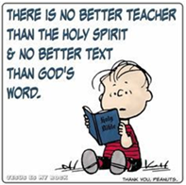Lectionary Scripture Readings
God inspired the Bible, and because of its divine origin, it is the final authority for all matters in our lives. It provides us with instructions to live in a God-honoring way, and it equips us with knowledge and wisdom for the works God calls us to do
October 2, 2022 – 17th Sunday after Pentecost
Luke 17:5-10 - Lamentations 1:1-6 - Psalm 137 - 2 Timothy 1:1-14
Joys & Concerns: Keep those prayers going and thank God for His answers! To add a prayer request or share a joy, please call the church and leave a message. (215) 745-7115 We should pray for one another because we need each other. Jesus never intended for us to live the Christian life alone.

Prayer requests September 18th
Mustapha Konneh was seriously sick and is now doing better. Thank you for prayers.
James Browne has prostate cancer- prayers for successful treatment and plan of care.
Continued prayers for Theresa (Cocoa's stepdaughter) and for her children, Chasity & Giovanni.
Barabara Brown has blood clots in her legs.
Barbara Berger broke her leg and ankle and will need surgery.
Hawah's baby that was born pre-mature and is still in the hospital.
For children with diabetes, cancer or other diseases.
Diana Wilson had successful cataract surgery this week.
Traveling mercies for Paul Wilson and all traveling this week.
Rose Burghaze has health issues and is not feeling well.
Prayers for our youth.
Continuing Prayers:
Pastor Randy & Family Sana Aman Zilpha Browne Dorothy Buzzard
Caroline (Burghaze’s Daughter) Rev. Khan Scott Meyer Ed Ingle Marva
Cass Quigley Betty Sauerwald & family Wondor Korto
Sylvia Spotts Suzanne Turner Hank & Eva Baumgartel
Prayers for the Ukraine and Russia - for world peace
Prayers for our city and end to violence
Prayers for peace and stability in Sierra Leone
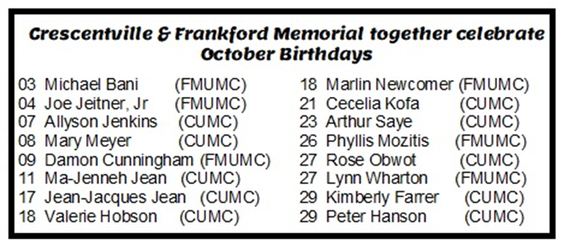

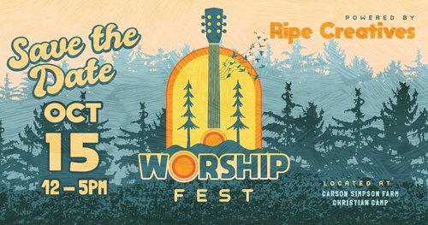
Carson Simpson Farm, in partnership with
Ripe Creatives,
presents Worship Fest.
This is a free community concert coming this October.
Date and time: Saturday, October 15, 2022 12:00 PM – 5:00 PM EDT

Location: Carson Simpson Farm Christian Camp, 3405 Davisville Road, Hatboro, PA

About this event
Worship Fest is to be held on October 15th from 12pm.-5pm, and will be a completely free festival for churches and the community.* The mission behind Worship Fest is to spread the gospel, through worship, arts, and community fellowship. Throughout the event, local church's Worship teams will perform and Ripe creatives will have hip hop artists, spoken word poets, artists, and Ripe's very own Worship team perform. We are so excited for this opportunity for every tongue, tribe, and nation to gather and worship our awesome God! We ask that you please confirm your attendance by purchasing a free digital ticket. A reminder that Carson Simpson Farm Christian Camp prohibits any smoking, drugs, and alcohol use.
.
IF YOU WANT TO ATTEND PLEASE TELL SUE SNYDER BY OCTOBER 9TH
SO THAT SHE CAN SECURE OUR FREE DIGITAL TICKETS.

Our heater replacement fundraiser will be ongoing until the goal is reached!

The initial bill for the church heating was $ 24,270.
Funds collected to date are $ 9,890
plus a grant for $ 5,000
= $14,890 Total funds for church heating.
We still need $ 9,380.00 to reach our goal.

Please continue to prayerfully consider giving a donation towards these costs. You can make as many tributes as you would like, contributing what you can as you can. Envelopes for donations are on the tables with the bulletins.

